
(For Office use only)
Application No.:

DATE:
PATENT PRODUCT/PROCESS
- IP support service required (Tick the appropriate service)
- Patent :
- Trademark :
- Copyright :
- Designs :

- Point of contact (PoC)
- 1st Point Of Contact
Name : S Rakesh Kumar
Mobile No. for contact : 6380764562
WhatsApp No. : 6380764562
Email : srakeshkumar2006@gmail.com

- 2nd Point Of Contact
Name :Dr. M. Pallikonda Rajasekaran
Mobile No. for contact :9443065795
WhatsApp No. :9443065795
Email : mpraja80@gmail.com

PATENT PARTICULARS
Name of the Applicant:

Inventors:
S.No | Inventor Particulars | Signature (Please Attach the JPEG of your signature)
1 | Name : S Rakesh Kumar  Designation : Autodesk fusion360  Department : ECE  Name of the College: kalasalingam Academy Of Research And Education  Email : srakeshkumar2006@gmail.com  Mobile No. : 6380764562  Whatsapp No. : 6380764562 | 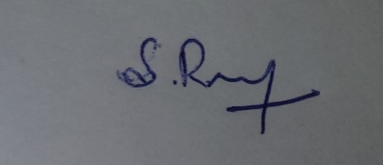
2 | Name : Dr. M. Pallikonda Rajasekaran  Designation : Professor  Department : ECE  Name of the College: Kalasalingam Academy Of Research and Education  Email : mpraja80@gmail.com  Mobile No. : 9443065795  Whatsapp No. : 9443065795
3 | Name : Dr.V.Muneeswaran  Designation : Associate Professor  Department : ECE  Name of the College: Kalasalingam Academy Of Research and Education  Email : munees.klu@gmail.com  Mobile No. : 9047017589  Whatsapp No. : 9047017589
4 | Name : Dr.P.Manikandan  Designation : Associate Professor  Department : ECE  Name of the College: Kalasalingam Academy Of Research and Education  Email : manip85@gmail.com  Mobile No. : 936100924  Whatsapp No. : 936100924

TITLE OF THE PROJECT:
MULTIPURPOSE FLIPKEY
Field of invention
The present invention relates to a multifunctional flip key assembly and, more specifically, to a 3D-printed modular housing developed using Autodesk Fusion360 computer-aided design (CAD) software.
Description of the related art
Traditional flip keys are cumbersome, heavy, and prone to structural damage when dropped. Their non-modular design prevents the repair of individual parts, leading to high replacement costs. Furthermore, professionals like industrial employees and professors often face pocket clutter and discomfort from carrying separate ID cards, pens, and ATM cards. This invention addresses these issues by consolidating all daily essentials into a single, durable, and cost-effective unit.
Description of the Invention
The innovative design features a front-mounted slot for an ID card and a top-facing compartment for a bike key. The side profile integrates a pen holder, while the entire housing utilizes an open-and-close mechanism secured by snap-fit joints. This tool-free assembly ensures that all components are held securely within a single, modular case
Figure 1 Shows the 3d model image of the case

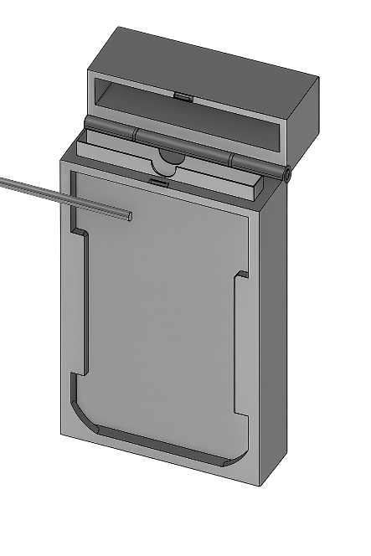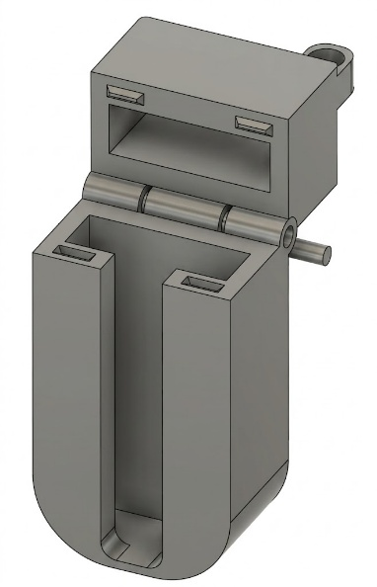

Parts definition:
- Bike key holder
- Pen holder
- Key holder
- ATM card holder
- ID card holder
- Snap fit case
- Snap fit jointer
- Jointer part in top and bottom
- Batch merging hole
Bike key holder
The flip key features a specialized top-mounted slot designed to securely house a bike key, providing a protective and convenient storage solution. This integrated housing prevents the key from bending or fracturing during accidental drops and eliminates the need for external keychains. By consolidating the key into the main body, the design significantly reduces pocket and belt clutter, resulting in a more organized and efficient user experience.
Pen holder
The flipkey includes a side slot specifically designed to hold a pen, allowing you to carry it conveniently with your daily essentials. This feature ensures you always have a pen ready—ideal for students or employees—saves pocket space, and helps prevent misplacing pens, making it a practical addition to your everyday carry.
Key holder
The flip key incorporates an auxiliary internal compartment designed to accommodate secondary keys, such as those for a residence, office, or locker. This integrated architecture eliminates the need for multiple, cumbersome keychains and prevents the misplacement or confusion of various keys. By centralizing all essential keys into a single, compact unit, the design ensures neat organization and immediate accessibility.
ATM card holder
The flip key incorporates a low-profile compartment engineered to securely house an ATM, debit, or credit card, offering a protective storage solution within the modular chassis. This integrated feature eliminates the necessity for a bulky wallet while shielding the card from mechanical bending, surface scratches, or accidental loss. Additionally, the design is optimized for rapid accessibility, ensuring seamless retrieval during financial transactions.
ID card holder
The flip key features a front-facing transparent aperture for an employee or student ID card, allowing for seamless display and rapid access. This integrated design consolidates identification with other daily essentials, effectively eliminating the need for a separate lanyard or ID strap. By housing the ID within a single, compact unit, the architecture provides a practical solution for professionals who require frequent identification

Snap fit case
The primary housing features integrated snap-fit joints , enabling a tool-free opening and closing mechanism. This modular design eliminates the need for screws or adhesives , allowing for the effortless insertion or replacement of internal components. By ensuring the device is reusable and easily repairable , this architecture significantly extends its functional lifespan.
Snap Fit Jointer
An integrated locking mechanism, such as a clip or latch, works with the snap-fit design to secure the top and bottom halves. This feature ensures a reliable closure and allows for tool-free assembly or disassembly. By providing a robust fastening system, the design maintains structural integrity during rigorous daily use. These sections support the snap-fit joints to ensure long-term durability
Jointer Part (Top and Bottom)
The flip key features integrated alignment sections that securely connect the top and bottom halves of the housing. These components ensure perfect structural alignment and provide the mechanical strength necessary for a smooth opening action. By supporting the snap-fit joints, these sections guarantee reliable performance and durability during daily use.
Batch Merging Hole
The flip key incorporates integrated alignment sections that securely connect the housing halves, ensuring structural integrity and precise alignment. These components provide the mechanical strength necessary for a smooth opening action while supporting the snap-fit joints for reliable daily use.
Advantages
- ID Card Slot in Front – An inbuilt space to insert and carry the employee ID card.
- Snap-Fit Case – Open and close mechanism with snap-fit design to keep items secure.
- Safe Storage for Keys & ATM Cards – Keys and money transaction cards are stored inside the case to avoid loss or damage.
- Inbuilt Pen Holder – A small pen stand is integrated within the case for quick access.
- Space-Saving Design – Combines multiple items (ID, keys, cards, pen) into one compact unit, reducing the need for extra pockets or belt loops.
- Safe & Comfortable – Provides safety and comfort for employees while working and travelling.

Abstract
Conventional flip keys are typically constructed from fragile, non-reusable plastic, making them highly susceptible to structural failure or breakage upon impact. Their lack of ergonomic optimization leads to frequent, costly replacements and contributes significantly to plastic waste, especially in industrial and IT environments where professionals must carry mandatory items like ID cards, pens, and transaction cards. This widespread inefficiency, characterized by pocket clutter and the discomfort of hanging heavy, easily damaged keys on belt loops, highlights the urgent need for a more durable, compact, and multifunctional solution.
A. INVENTION TITLE AND SHORT DESCRIPTION: Please provide the title and also a short description about the invention. (What’s the invention about?)
Multi Purpose Flip key
This multifunctional product is specifically engineered for industrial environments and working professionals. It features an integrated ID card slot, a pen holder, a bike key compartment, and a secure space for an ATM card, consolidating all daily essentials into a single unit. By housing these items within a durable, 3D-printed chassis, the design ensures they remain protected from structural damage or loss, even if the device is accidentally dropped.
B. PROBLEM: What overall problem(s) does the proposed invention solve or what purpose does it serve? (Note: Please be specific, spell out acronyms and provide enough layman level detail to fully explain the problem.)
Industrial employees and working professionals often face the inconvenience of carrying essential items like ID cards, ATM cards, and bike keys, which consume excessive pocket space and cause physical discomfort during work. Furthermore, traditional bike keys are prone to damage from accidental drops, leading to worn grooves and ignition issues, while standard flip keys are often heavy, expensive to replace, and have non-repairable internal mechanisms. To resolve these challenges, this 3D-printed multipurpose flip key uses a custom CAD model to integrate a front-facing ID slot, a top-mounted bike key holder, an ATM card compartment, and a lateral pen holder into a single unit. This innovation significantly reduces maintenance costs and plastic waste by allowing individual damaged parts to be redesigned and reprinted at a low cost.
C. EXISTING SOLUTIONS / PRIOR ART/RELATED APPLICATIONS & PATENTS:

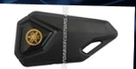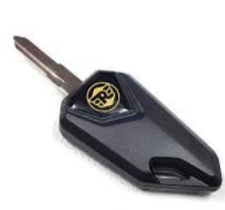

C1. How your invention solves the problem?
I have developed a multipurpose flip key model using a custom CAD design that integrates a front-facing ID card slot, a top-mounted bike key holder, an ATM card compartment, and a lateral pen holder. This 3D-printed solution significantly reduces maintenance costs, as damaged parts can be easily redesigned and reprinted at a low cost. Furthermore, the design optimizes pocket space and enhances user comfort while providing a protective housing that prevents the key from being damaged during accidental falls. This robust architecture ensures the device remains durable for long-term use.
C2. What is the unique feature or advantage of your invention over existing solutions?
Reduce cost, Easily Repair, Redesign ,Reusable, Eco friendly, Reduced plastic wastage ,Avoid over damage, Multipurpose
D. DESCRIPTION OF PROPOSED INVENTION:
The multipurpose flip key addresses the common challenge of carrying multiple keys, cards, and daily essentials in a bulky, disorganized manner by consolidating all items into a single, compact unit. The primary housing is engineered with snap-fit joints, allowing for secure assembly without the need for mechanical fasteners or adhesives, which ensures the device is both reusable and easily repairable. A specialized top-mounted slot securely houses a bike key to prevent mechanical failure, while a lateral pen slot and an auxiliary compartment for secondary keys optimize pocket space and improve organization. Additionally, a low-profile compartment protects ATM or credit cards from structural damage, and a front-facing transparent aperture allows for rapid ID identification without a separate lanyard. Together, these features minimize clutter and provide a lightweight, durable, and practical solution for professionals and students alike..
D1. How does your invention work?
This multifunctional product is engineered for industrial environments and working professionals, consolidating an ID card holder, pen holder, bike key slot, and ATM card compartment into a single, compact unit. The reinforced chassis ensures that all internal components remain secure and functional, even in the event of an accidental drop. Lightweight, durable, and intuitively organized, this 3D-printed solution streamlines your daily carry while maintaining a sophisticated, professional appearance.
D2. What are the specific steps involved in making the invention?
The design of the multipurpose flip key is based on strategic dimension planning and precise input gathering to ensure seamless integration of all daily essentials. The architecture features dedicated compartments for a bike key, secondary keys, a writing instrument, ATM/credit cards, and a standard ID card, all secured by a robust snap-fit and locking mechanism. To ensure a universal fit, the design adheres to industrial standards, accommodating keys of 50–60 mm in length, pens with an 8–10 mm diameter, and standard ISO/IEC 7810 cards. The overall chassis dimensions—approximately 150 mm x 70 mm x 20 mm—are optimized for portability, while functional clearances of 0.5–1 mm and tolerances of 0.2–0.3 mm ensure smooth insertion and retrieval. Finally, the inclusion of rounded edges and ergonomic spacing ensures comfortable handling, making the device a durable and practical tool for daily professional use.

D3. Are there any alternative applications for your invention?
Beyond its primary function of organizing keys and cards, the multipurpose flip key offers significant versatility across various professional and personal domains. It serves as an optimized travel companion for housing transit passes and hotel key cards, while its modular chassis can be adapted into a compact emergency kit for storing a safety whistle or a mini-flashlight. Students and academic professionals can utilize the device to secure ID cards alongside small stationery items like USB drives, and the design can even be upgraded with RFID or NFC modules for smart access in secure office environments. Whether used as a minimalist wallet for medical information or a customizable corporate gift, this 3D-printed solution provides a secure, lightweight, and adaptable platform for organizing a diverse range of daily essentials.
E. NOVELTY and KEY FEATURES:
The flip key’s novelty lies in its 3D-printed, modular design that integrates multiple functions—including secure storage for bike keys, secondary keys, pens, ATM/debit cards, and ID cards—into a single compact, reusable, and durable unit. Unlike conventional flip keys, which are typically fragile, single-purpose, and non-reusable, this innovation utilizes snap-fit joints, a robust locking mechanism, and an ergonomic layout to ensure a uniquely customizable and lightweight experience. Optimized for daily use and material efficiency, the design effectively sets itself apart from prior art by offering superior functionality and structural longevity.
E1. Are there any existing patents or prior art that may impact the patentability of your invention?
While existing patents cover conventional flip keys, compact organizers, and hybrid card-storage devices, this invention remains distinct through its unique all-in-one integration of a bike key, secondary keys, a writing instrument, and multiple card types. Unlike traditional multi-key holders typically manufactured from metal or rigid plastic, this design utilizes a 3D-printed modular architecture with snap-fit joints and an integrated locking mechanism for ease of repair and assembly. Furthermore, the ergonomic layout and the potential for RFID or NFC integration differentiate it from prior art by offering a smart, sustainable, and multifunctional platform. Although a comprehensive patent search is recommended to confirm total novelty, the specific combination of these features makes this flip key a unique and superior alternative to current market solutions.
F. COMPARISON: Please provide advantages and basic differences of the proposed solution over previous solutions.
Normal Flip key
- Manufacturing: Mass-produced using traditional methods (injection molding, machining).
- Customization: Limited — usually comes in standard shapes and sizes.
- Repair/Replacement: Requires ordering from the manufacturer or locksmith; time-consuming and costly.
- Cost: Generally low for standard keys but higher for specialized replacements.
- Design Flexibility: Fixed; can’t easily modify.
- 3D-Printed Flip key
- Manufacturing: Produced with 3D printing technology — faster prototyping and production.
- Customization: Highly customizable in terms of size, shape, ergonomics, and even branding (logos, names).
- Repair/Replacement: Quick and low-cost reprints possible with the design file — no need for manufacturer dependency.
- Cost: Cost-effective for small-scale or personalized production; reduces inventory waste.
- Design Flexibility: Easy to innovate and modify designs digitally before printing.
- Innovation Edge: Can integrate smart features (e.g., RFID, sensors) more easily compared to normal flip keys.
G. CLAIMS:
1. Multi-Functional Integration: Combines bike key, secondary keys, pen, ATM/debit card, and ID card storage in a single compact unit.
2. 3D-Printed Modular Design: Lightweight, durable, and customizable; each part can be individually reprinted or replaced, reducing waste and cost.
3. Snap-Fit & Tool-Free Assembly: Allows easy assembly and disassembly without screws or glue, ensuring reusability and eco-friendliness.
4. Ergonomic & Space-Saving Layout: Organizes all essentials safely and accessibly, minimizing pocket or belt clutter while preventing damage or loss.
5. Novelty & Sustainability: It integrates multiple daily-use items into a single reusable, lightweight, and environmentally friendly product, offering functionality that conventional flip keys or card holders cannot provide.
H. ADDITIONAL INFORMATION: Please provide additional information such as, a claim set, drawings, a software code, etc.)
The multipurpose flip key project is supported by a comprehensive technical framework, including a detailed claim set, engineering drawings, and potential software integration. The claim set defines the invention’s unique features, such as the dedicated bike key slot, lateral pen holder, secondary key compartment, and a front-facing transparent ID aperture—all unified within a modular, snap-fit chassis. To ensure structural clarity, the documentation includes orthographic projections (top, side, and front views) and exploded-view diagrams that illustrate the assembly of individual components alongside high-resolution 3D CAD renderings. Furthermore, the design is prepared for smart adaptations through RFID/NFC integration, with sample code provided to demonstrate card detection and access control functionality. Finally, a complete Bill of Materials (BOM)—detailing the main body, snap-fit joints, locking mechanisms, and optional electronic modules—provides a thorough overview of the device's design, manufacturing feasibility, and practical utility.
Have you conducted any testing or experiments on your invention? If so, what were the results?
1. Functional Tests
- Fit Test → Does the 3D-printed flip key fit correctly into locks (car/bike/door)?
- Turning Force Test → Can it withstand the torque when turning the lock without breaking?
- Flip Mechanism Test → Does the flipping action open/close smoothly like a normal flip key?
2. Durability & Strength Tests
- Drop Test → Drop from different heights (pocket, table, hand level) to check breakage.
- Wear & Tear Test → Repeated flipping and usage cycles to simulate long-term use.

- Temperature/Weather Test → Exposure to heat, cold, and humidity to check material stability.
3.Material & Safety Tests
- Material Strength Test (tensile/compression) → Ensures the 3D-printed material is strong enough.
- Chemical Resistance → Resistance to oils, sweat, cleaning liquids, etc.
- Safety Check → No sharp edges or harmful residues from printing.

I.OBJECTIVE OF THE INVENTION

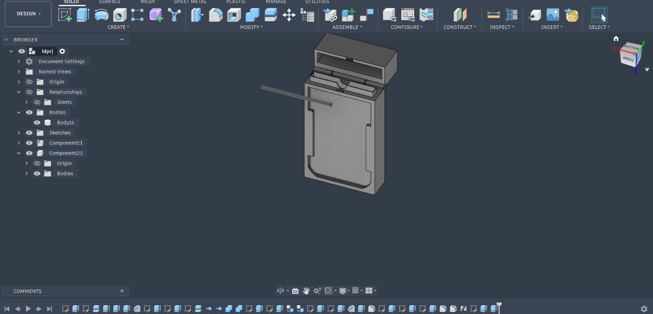

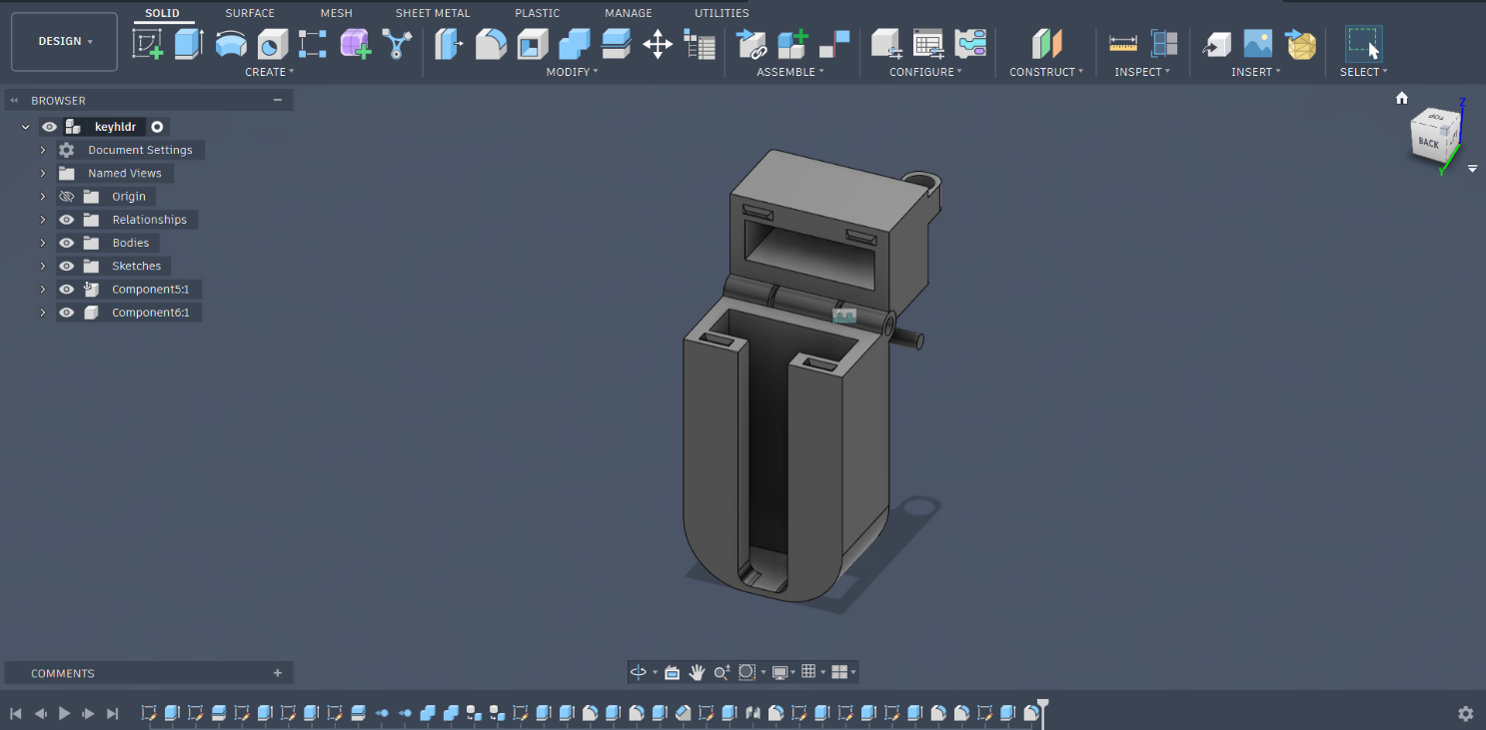

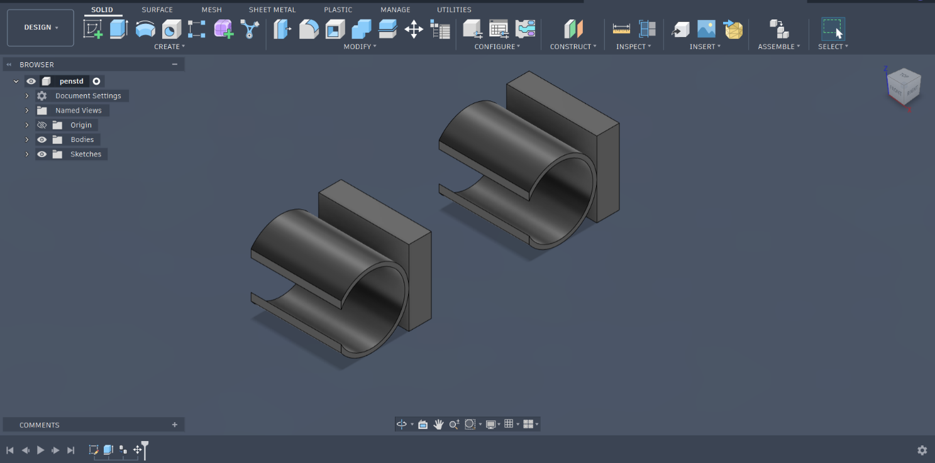

J. DRAWINGS

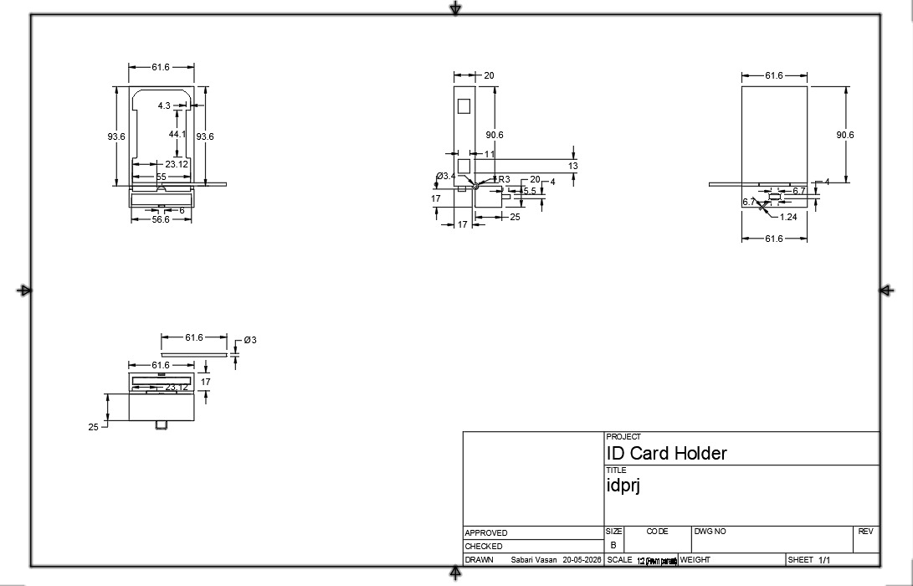
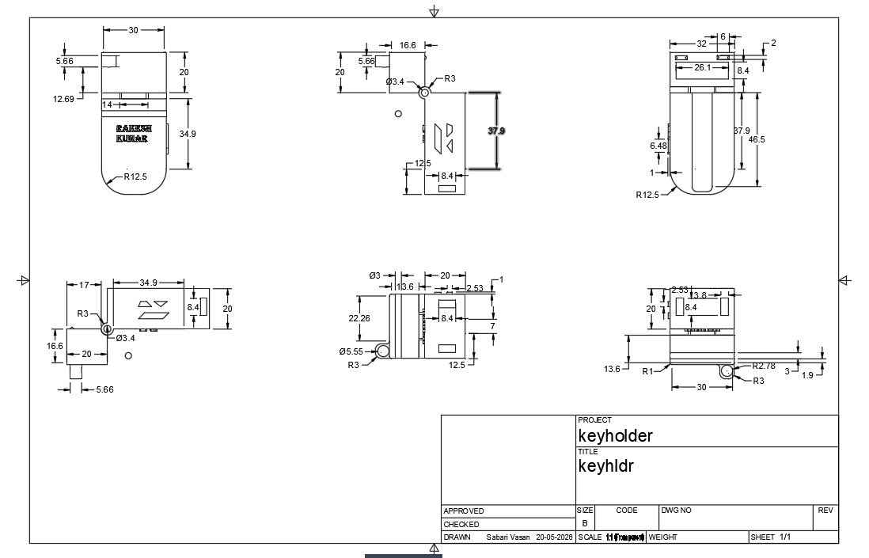

DISCLAIMER

I /We the undersigned inventor(s) through our activities at _____________________________
______________________________________, hereby declare that any information pertaining to the above furnished inventions for design filing are results of my /our true works. I /We acknowledge that the company is accepting this information for review purpose only. I /We also understand that any comments, suggestions, reports, etc which I/We receive review based upon this analysis is neither meant nor understood to be a conclusive legal opinion. Further I /We agree that the company cannot be held responsible for acceptance or rejection or any other office actions of my /our inventions, creations, Patent, copyrights, trademarks, designs by appropriate authorities. I / We whole heartedly accept the verdict finalized by the patent office whether it is positive or with adverse results and I/We will not blame the company for such reasons. However, the company will support the inventor(s) by replying to FER queries or technically assist the inventor(s) with modified designs which paves easy way for awarding grant certificate. Hereby disclose this “Invention” to the company on the date signed below.

Date:
Place: Signature

